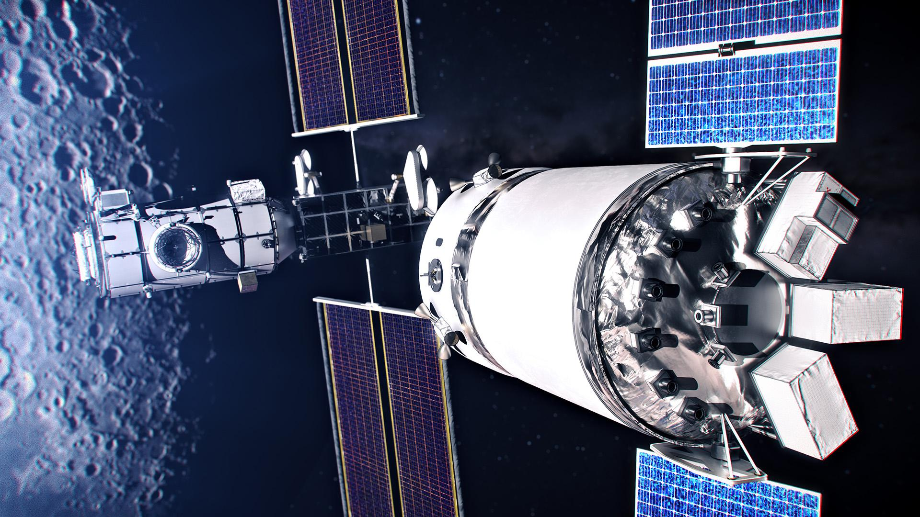

**Case-study about SpaceX Data**

* **SpaceX has revolutionized the Aerospace industry with the power of Data to drive innovation,improve efficiency and accelerate progress in space exploration.**
* **Here are a few examples about the importance of data in decision making in SpaceX**

| A pink and purple circle with a green ball in balancing on the left bottom part of the ring. |  | **Launching and landing Rockets:** **SpaceX employs hundreds of sensors on rockets to gather telemetry data (position, velocity, altitude) and environmental data (temperature, air pressure, wind speed) during launch. This data is transmitted in real-time to Mission Control, providing a comprehensive view of the rocket's status.**  **Data from multiple sensors**  **(IMUs,GPS,radar,etc.) to**  **Provide accurate state estimates,enabling for navigation,control and landing.** |
| --- | --- | --- |
|  |  |  |

| **Deep Space Navigation:**  **In deep space, where communication delays can be significant, autonomous navigation is crucial.**  **SpaceX uses AI to enable spacecraft to navigate complex environments, avoid obstacles, and optimize trajectories without constant ground control.**  **This includes using algorithms to analyze images of celestial bodies, such as asteroids and planets, to determine the spacecraft's position and adjust its course.** |  | Peach sphere coming out of a tube on a balancing see saw. |
| --- | --- | --- |

| a white ball on a striped blue surface |  | **Deep Space Planning:****SpaceX utilizes data to model the challenges of deep space logistics, including radiation shielding, redundant transportation modes, and buffer management, crucial for long-duration missions to the Moon and Mars.** **Customer Feedback:****Feedback from customers regarding payload requirements, mission objectives, and operational needs is integrated into SpaceX's planning processes, ensuring their services align with market demands.** |
| --- | --- | --- |